Name:U.P.A.R Vidushani
Student Reference Number:10707397

Module Code: CNET343SL | Module Name: Distributed systems
Coursework Title: Project Proposal: Edu- Master
Deadline Date: 03/12/2021 | Member of staff responsible for coursework:  Mr. Pramudya Thilakarathna
Programme: BSc(Hons) Software Engineering
Please note that University Academic Regulations are available under Rules and Regulations on the University website www.plymouth.ac.uk/studenthandbook.

Group work: please list all names of all participants formally associated with this work and state whether the work was undertaken alone or as part of a team. Please note you may be required to identify individual responsibility for component parts.

Name | Plymouth Index
U.P.A.R. Vidushani | 10707397
R.M.N. Dhananjani | 10707176
K.G.U.K.E. Dayarathne | 10707158
M.K.S.S Meegoda | 10707280
L.A.L Fernando | 10707192
R W S V Rambukwella | 10707338

We confirm that we have read and understood the Plymouth University regulations relating to Assessment Offences and that we are aware of the possible penalties for any breach of these regulations. We confirm that this is the independent work of the group.

Signed on behalf of the group: 

Use of translation software: failure to declare that translation software or a similar writing aid has been used will be treated as an assessment offence.

I *have used/not used translation software.

If used, please state name of software…………………………………………………………………
Overall mark _____% Assessors Initials ______ Date_________
*Please delete as appropriateSci/ps/d:/students/cwkfrontcover/2013/14
Content
Chapter 1 Overview 4
1.1 About us 4
1.2 Background and motivation 4
1.3 Introduction 7
Chapter 2 Business case 8
2.1 Target users 8
2.2 Underlying problem 9
2.3 Business objectives 9
Chapter 3 Project objective 10
Chapter 4 Application features 10
Chapter 5 Method of approach 10
5.1 application technologies 11
Chapter 6 Project plan 11
6.1 Time frame 12
6.2 6.2 Communication plan 12
Chapter 7 Reference 13
Chapter 8 Evaluation of work 15

Content of tables and figures
Chapter 1 Overview 4
1.1 About us 4
1.2 Background and motivation 4
Table 1.2.1 Main applications taken into motivation
Table 1.2.2 Other applications taken into motivation
Table 1.2.3 Motivation for forums
1.3 Introduction 7
Chapter 2 Business case 8
2.1 Target users 8
2.2 Underlying problem 9
2.3 Business objectives 9
Chapter 3 Project objective 10
Chapter 4 Application features Error! Bookmark not defined.
Diagram 4.1 Rough UML Activity diagram
Chapter 5 Method of approach 11
Figure 5.1 Simple diagram of Edu-master
5.1 Application technologies 11
Table 5.1.1 Basic technologies planned to be used
Chapter 6 Project plan 11
Table 6.0. Project plan
6.1 Time frame 12
Figure 6.1.1 Grantt Chart
6.2 Communication plan 13
Table 6.2.1 Communication plan
Chapter 7 Reference 14
Chapter 8 Evaluation of work 14

Overview

About us
Almost all the sectors and occupations were moving forward to a satisfactory level with the use of technology. But now adays a lot of occupations have become comfortable in the virtual world in a rapid manner. Each of these occupations have found a way to move on with their livelihood with the help of diverse technologies due to the current pandemic situation worldwide. This is where Distance education was introduced to each part of the world when we consider education sector.
Distance learning have been a famous subject to talk about these days as people have gone through diverse hardships and met with a lot of opportunities and benefits with these latest introductions. But are these technologies and applications enough to satisfy the current needs in education sector?
Edu-master is an application which help moving forward with current technologies in a much interesting and easier manner. This application is possibly to be used by any person who is willing to learn and share their knowledge with the rest of the members about Whatever they are interested about. This application can be used for more other things than just education, but this is mainly what this application is supposed to be used for due to valid reasons.

Background and motivation
Edu-master is and application which was motivated with the functions of Microsoft teams and club house application, the features and technologies are given below.
Application and Technologies | Features
- Club House  For android and IOS  - Written in kotlin,  - backend phyton and Django  - Runs on Gunicorn server  - load balancing -HAProxy  Available on desktops as clubdeck | - Only allow audio broadcasting  - Clubs regularly discuss the common interests of the community members. Consists of  - Admin- can modify club settings  - Leaders-create, schedule any type of room  - Members- Can create private rooms and invite members to the club  - Consists of Rooms of different types, one can decide the type of the room they need when creating  - Open rooms- anyone can join  - Social rooms- users should follow moderators can join  - Closed rooms- invited only by the moderator  - Events- occur spontaneously or the scheduled by user by entering the name of the event, date, and time. Co-hosts can be added to help moderate the event. These events created are shown in the bulletin.  - Back channel- allows users to interact individually or group vice via text.  Key words:  Stage- Speakers speak here  Moderator-person who create the group,  can call users to the stage (available the unmute option to that user), can mute users/ remove speakers from stage  Listener- Person who joins to a group, cannot unmute themselves unless they raise a hand and let the moderator know that you need to speak in stage. Exiting a room can be done using the peace sign or leave quiet option.
- Teams  For Android, IOS, windows, macOS, Web  - Use TypeScript, Angular, React and Electron  - Video conferences - MNP24 protocol | - Messaging- Group or one-on-one chat  - Calling – Voice over IP calls among Team’s clients (cloud-based telephony for voice calling)  - Video meetings- Virtual meetings with key video conferencing options like Virtual backgrounds  - Channels- Members set up channels Members can set up channels.  - Meeting recording, transcription, whiteboarding and breakout rooms. Video meetings can be scheduled on a channel’s calendar  - File sharing- store, share and edit files. Also, users can collaborate on the same document in real-time  - Private Channel- Keep conversation private among users.  - End to end encryption  - Safe Links- help to protect from any malicious site when peoples click links  - Meeting controls- Disable video, Invite-only option
Table 1.2.1 Main applications taken into motivation
Other than that, the below applications also help the authors choose and understand the objectives, features, and ideas about the application.
Application and Technologies | Features
- Zoom  For Android and IOS  - Frameworks: Android, ionic.  - Tools: IOS SDK, Android studio, apple code, android SDK, visual studio  - Backend: Objective C and swift for IOS applications, java and Kotlin for android application  - Third- party API’s: Wowza GoCoder SDK, Vonage Video API (formerly TokBox OpenTok), Twilio, CometChat, PubNub, Quickblox  Web based application:  - API: WebRTC APIs (MediaStream, RTC DataChannel, RTC PeerConnection, and real-time chat and communication API like Pubnub, OpenVidu, CometChat etc.)  - Frontend: HTML, CSS, and JavaScript  - Back end: React JS, Angular JS, and Vue | - Offer meetings and chat (with or without video and screen sharing)  - HD video audio calls  - One-on one chat or team chat  - Consists of rooms  - Email services  - Calendar  - Virtual hand raising  - Virtual backgrounds  - Polls and Q&A  - Option to record meetings  - Mute participants  - Schedule meetings  - Multi-screen video and screen sharing
- Telegram  For Desktop app  - Languages: Objective C, C++, C  - Made with: Qt  For android app: java programming language  For iOS app  - Objective C and Swift  For the Web app  - Angular js  - Node js  - MTProto Mobile protocol for speed  - Diffie Helman key exchange for authentication  - Telegram Database Library for all network implementation details, encryption and local data storage  - Messaging protocols like Web Sockets and XMPP are used as instant messaging protocols  - HTML5,  - Google Analytics  - Google Workspace,  - Viewport Meta,  - Google Font API. | - Cloud based messages  - Channels  - Bots  - Video and voice calls  - Polls  - Chat folders  - Larger File Send Size  - Video screen sharing  - Cloud storage  Customize Theme and Message Corners  Lock Conversations  - Digital stickers  Free Unlimited Online Storage  - Edit sent messages  Send Uncompressed Media  Add People Based on Your Location  - Broadcast groups  - Improved reporting system  - Expiring invite links  - Scannable QR codes for invites  - Home screen widgets  - Improved chat import feature  - Upload multiple profile pictures
- Google meet  WebRTC (for real-time audio, video and data transmission through web and native browsers).  ● Go programming language – Introduce by the google, bit like C++.  ● P2P Architecture (each node has same responsibilities and capabilities) | - Can host unlimited number of meetings  - Live captions  - Can be used in multiple platforms  - Can preview  - Host have control  - Screen sharing  - Messaging  - Intelligent noise cancellation  - Dial-in phone numbers
Table 1.2.2 Other applications taken into motivation

Other than these applications authors also have used the knowledge on stack overflow to take and idea about forums section.
Name | Features
- Stack overflow  Language C#  - Database-Microsoft SQL server  - Made using ASP.NET MVC (model-view-controller) framework  - Data access- Dapper object related mapper | - Can ask questions  - Can vote  - Edit questions and answers  - Earn reputation points and badges  - New privileges are given when having badges  - Provide Tools to brand a business of someone  - Advertising  - Unregistered can only see or read the questions and answers
Table 1.2.3 Motivation for forums

Introduction
Today students and teachers use many applications for these educational purposes. As an example, Zoom, Microsoft Teams, Google meet, etc. These platforms give audio, video conferencing and chat facilities to the users. Most educational institutes also use those kinds of platforms for teaching purposes. Also, educational institutions use Learning Management Systems (LMS) for upload their lecture materials and forums. For communication purposes use telegram application. Some applications like ‘Clubhouse’ use for group discussion purposes. In clubhouse, user can choose the topic and join for the conversation. Other applications like Microsoft Teams, there are options for upload the documentations and other materials(Adzharuddin, 2013).
According to the above descriptions, there are many applications for distance learning / online learning and group communication. But no single application therefore all these applications are currently done by switching applications and some of these applications are to be bought.
Assume, one user joins for meeting by using one of these applications, but unfortunately unmute and make a disturbance to the meeting. This happens because the meeting host cannot control the user end. But in clubhouse, a listener can request to speak in stage, then moderator can give permission to speak. Edu master is a single application made using all these types of helpful features.

Business case

The problem that the project analysis encountered is when clients are looking about and using features of current team collaboration related platforms are limited and different from one to one; sometimes, the processes of using those are very hassled full and tedious. Which commonly affects all parties who are already engaged in using. If going to analyse those issues,

As a student or a learner

- Difficult to find and gather users related to their expected knowledge area.
- Expecting to explore share knowledge without spending money and most of the time doing that is not easy as a student
- Difficult to share learning materials with others easily.
- Expecting to be easy and hassle less communication between users.
- Unexpectedly, users getting rid of control of the platform threatens their privacy.
- Want to switch between various platforms for access and use features.
- Structure of file handling confound their learning efficiency
- Limited flexibility leads to time wasted
- Similar and redundant tools availability confusing its works.

As a professional or a teacher,

- Difficult to find a related group of users to share their experiences and knowledge.
- Difficult to focus on users when needed to communicate.
- Most of the time, getting disturbed because of unexpected activities occur from users.
- Difficult to find a comfortable and straightforward virtual meeting control.
- Unexpectedly, users getting rid of control of the platform threatens their privacy.
- Want to switch between various platforms for access and use features.
- Complicated systems slow down their tasks.

Target users
According to the features of this application the target users are basically everyone who is interested on learning and teaching.
The party who is willing to learn can possibly be a student of any grade or any university or anyone other than that.
The party willing to teach can possibly be anyone who is willing to teach, a teacher, a fellow student, a lecturer or a professional, this teaching can be done with payments or free of charge.

Underlying problem
- No one platform for the student needs (Too much app switching)
Once we consider a situation where you need to work in group while learning at distant, then user have to use an application like, WhatsApp for communicating as a group to remind the meeting time, date, and content to be discussed. Users have to use an application like zoom, google meets, teams for conducting the meeting if the leader needs to present something. If there is any issue on the application in the middle of the presentation, then user have to switch into diverse applications.
- All the platforms for education are quite formal
Most of the current platforms are quite formal. This is mostly as they are centralized systems. This centralized platform may course diverse issues and exceptions. This application paves a way to treat all users equally.
- No one platform where all type of clients willing to learn and teach can work together
Other than forums and certain applications there are no specific applications where there is an ability for the users to meet with professionals who can officially help them.
- No official free online education platform
Mostly there are certain ways of payments for education purposes when we consider current system. There is a certain demand for free education currently due to economic difficulties and educational boundaries

Business objectives
There are diverse objectives for this business idea, these can be, creating a,
- Cost effective software with maximum benefits for the users
- User friendly GUI
- Cross platform software
- Free of charge
- Free education
- All needed features for a student in one application
- Can be used in both desktop and mobile device
- Easy accessing data
- Minimal use of databases
- Most features are real time
- End to end encrypted
- Easy signing in

Project objective

- Expansion of free education worldwide
- Easy learning platform for all users
- Minimize app switching
- Less formal platform
- Have assignments and notes in one place
- Ability to go for lectures held in any part of world
- Available public groups
- Enhance teamwork and collaboration between users
- Easy access for regularly used applications
- Public or private forums to ask questions and widen the knowledge

Application features
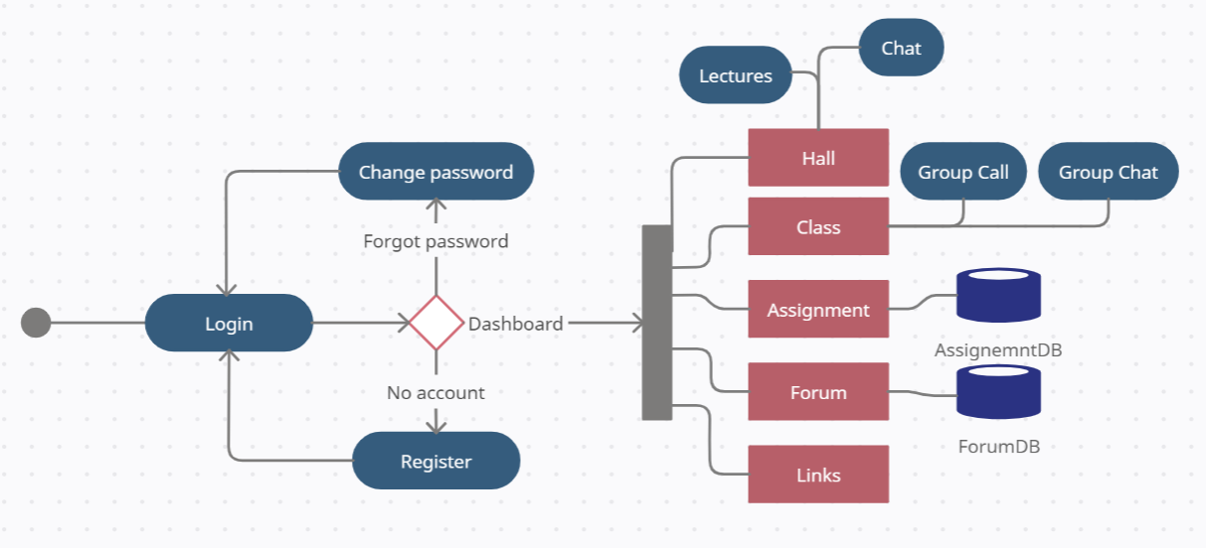
Diagram 4.1 Rough UML Activity diagram

- Consists of halls and classes
  - Halls: A hall is created by a user. He gets the ability to create the group choosing:
- Type of the subject he is willing to teach
- Name of the hall
- Display image
- Co-hosts
- Accessibility
- Forum type
After creating the group, he is considered as a moderator.
The moderator can give lectures and make schedules for events on the calendar.
Every member who joins the platform is a listener only, the listener needs to click on raise hand option to let the moderator know he needs to speak, then only the moderator will allow speaking as he pleases.
  - Class: A private group where you can add members with invitations. This is a small group of maximum 8 members which you can use for small discussions.
  - Able to pin special messages on top
- Consists of an assignment icon
  - Able to follow the CRUD concept on assignments.
  - Can share assignments in private or public groups
- Consists of a forum
- The forum can be private or public.
- Can add questions and answer freely if public, else only the hall members can ask or answer the questions of the specific forum
- Consists of diverse useful links such as, one-drive, outlook, g-mail etc.

Method of approach
It is planned to use a P2P architecture in this application since this application is mostly based on real-time data.
A client can access this application using a mobile as well as a desktop. Once the user opens the application, he must enter a valid email address. An OTP code is sent to the relevant email address later and one need to enter the code on the UI slot. Then only you can proceed further.
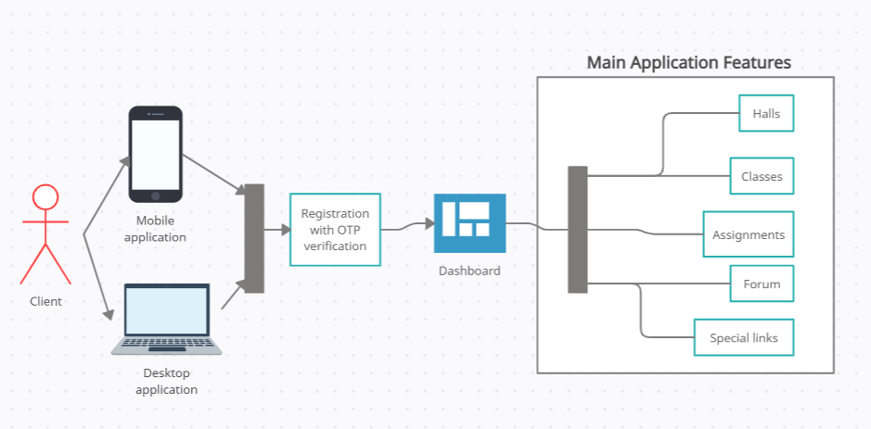
Figure 5.1 Simple diagram of Edu-master

5.1 Application technologies

Application or the technology used | Reasons
- Flutter | - Open source  - cross platform (IOS and Android).  - Less time consuming  - Feature rich
- Mongodb | - Open source  - User friendly  - Highly scalable  - Flexible  - High security as encrypted with TLS
- Netbeans | - Opensource  - Feature rich  - Cross platform  - Easy to use  - Used for network socket coding
- HA proxy | - Load balancing
- Wowza Go Coder | - For live streaming
- Extensible messaging presence protocol (XMPP) | - For instant messaging (real time)
- Google OTP service | - For SMS verification
Table 5.1.1 Basic technologies planned to be used

Project plan

Stage | Deadline | Deliverables
- Project idea | 20/11/2021 | - Discuss and finalize the project idea
- Investigation and requirements | 25/11/2021 | - Analyse the existing problem into main parts  - Requirement gathering (Documents)  - Get further information about similar systems  - Required Technologies
- Initiation | 03/12/2021 | - Project proposal
- High level design | 19/12/2021 | - Document analysis  - ER diagram  - Data Base structure  - Main system structure  - UML diagrams  - GUI design of then desktop and mobile application
- Assignment option | 29/12/2021 | - Choose methods of following CRUD concept  - Create the database for the assignments part  - Connecting the database with the UI of desktop and mobile application
- Chat option | 10/01/2022 | - Feasibility and change of the chosen technologies  - Creating database creation and connection
- Call option | 20/01/2022 | - Adding audio/video call facility to the user  - Schedule lectures with the additional features  - Connect audio/video call facilities to the system
- Forum option | 29/01/2022 | - Adding the needed features and developing them
- Security | 10/02/2022 | - Adding the licence agreement  - Analysing the possible threats
- Connecting possible links | 20/02/2022 | - Adding the essential links for a user
- 10. System and user acceptance testing | 16/03/2022 | - Make a survey for get ideas from external parties  - Finalize the system and testing  - Functional testing for mobile and desktop applications
- 11. Assemble and complete final report | 29/03/2022 | - Final project report
Table 6.0 Project plan

Time frame
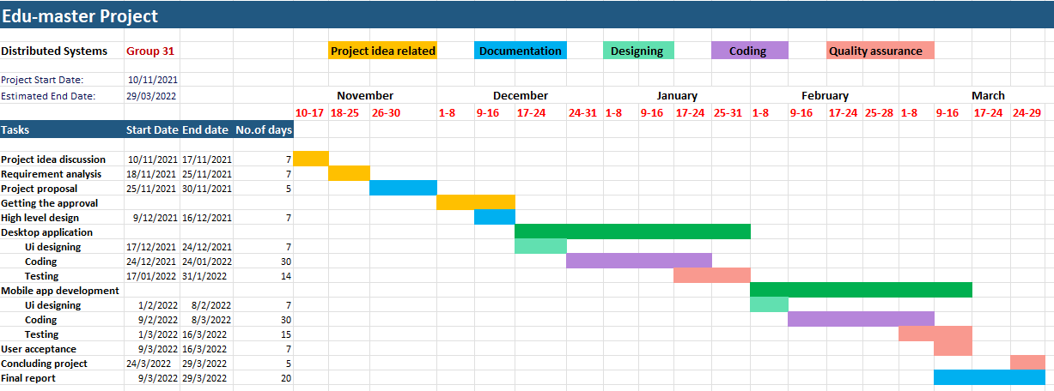
Figure 6.1.1 Grantt Chart

Communication plan

Since the project is planned for an approximate period of 4 months, a continuous communication must be maintained to ensure the success and the maximum quality of the proposed project. Therefore, the authors of this study (the group members) will be in contact in a frequent basis with the intention of discussing about the ongoing project status, arising problems and challenges or any other matters which are directly/indirectly related to the project development. Such communication will be carried out weekly and as per the requirements within the project timeline as summarized below.

Description | Frequency | Communication Channel | Participants
Project status updates | Weekly | Zoom/MS Teams/Google meet | All
Discussions on any issues/challenges | As required | Zoom/MS Teams/Google meet | As required
Important notices | As required | WhatsApp | All
Discussions on project features and ways to implement them | Once in two weeks | Zoom/MS Teams/Google meet | All
Suggestions on any ideas | Weekly | WhatsApp/Google meet/Zoom | All
Table 6.2.1 Communication plan

Reference

- Konstantinfo.com. 2021. [online] Available at: <https://www.konstantinfo.com/blog/zoom-video-conferencing-app/> [Accessed 28 November 2021].
- En.wikipedia.org. 2021. Zoom (software) - Wikipedia. [online] Available at: <https://en.wikipedia.org/wiki/Zoom_(software)> [Accessed 28 November 2021].
- Mindbowser. 2021. Guide To Build A Video Conferencing App Like Zoom. [online] Available at: <https://www.mindbowser.com/guide-to-build-a-video-conferencing-app-like-zoom/> [Accessed 28 November 2021].
- HuddleCamHD. 2021. A Technical Review of Google Meet. [online] Available at: <https://huddlecamhd.com/a-technical-review-of-google-meet/> [Accessed 28 November 2021].
- Medium. 2021. WebRTC — The technology that powers Google Meet/Hangout, Facebook Messenger and Discord. [online] Available at: <https://medium.com/swlh/webrtc-the-technology-that-powers-google-meet-hangout-facebook-messenger-and-discord-cb926973d786> [Accessed 28 November 2021].
- SearchUnifiedCommunications. 2021. What is Microsoft Teams? Everything You Need to Know. [online] Available at: <https://searchunifiedcommunications.techtarget.com/definition/Microsoft-Teams> [Accessed 28 November 2021].
- The thoughtstuff Blog. 2021. Under the Hood of the Microsoft Teams Desktop Application. [online] Available at: <https://blog.thoughtstuff.co.uk/2017/04/under-the-hood-of-the-microsoft-teams-desktop-application/> [Accessed 28 November 2021].
- En.wikipedia.org. 2021. Microsoft Teams - Wikipedia. [online] Available at: <https://en.wikipedia.org/wiki/Microsoft_Teams> [Accessed 28 November 2021].
- HuddleCamHD. 2021. A Technical Review of Google Meet. [online] Available at: <https://huddlecamhd.com/a-technical-review-of-google-meet/> [Accessed 28 November 2021].
- Medium. 2021. WebRTC — The technology that powers Google Meet/Hangout, Facebook Messenger and Discord. [online] Available at: <https://medium.com/swlh/webrtc-the-technology-that-powers-google-meet-hangout-facebook-messenger-and-discord-cb926973d786> [Accessed 28 November 2021].
- Nast, C., 2021. Meet Go, Google’s New Programming Language. [online] Wired. Available at: <https://www.wired.com/2009/11/google-announces-a-new-programming-language-google-go/#:~:text=and%20C%2B%2B.-,The%20language%20is%20called%20Go%2C%20and%20it%20was%20released%20under,source%20licenses%20over%20the%20years> [Accessed 28 November 2021].
- Apps.google.com. 2021. How to Use Google Meet Video Conferencing | Google Meet. [online] Available at: <https://apps.google.com/intl/en/meet/how-it-works/> [Accessed 28 November 2021].
- Support.google.com. 2021. Use Google Meet on the web - Google Workspace Learning Center. [online] Available at: <https://support.google.com/a/users/answer/10519038?hl=en> [Accessed 28 November 2021].
- Gupta, K., 2021. What Programming Language is Telegram Written In. [online] Developers, Designers & Freelancers – FreelancingGig. Available at: <https://www.freelancinggig.com/blog/2018/08/02/what-programming-language-is-telegram-written-in/> [Accessed 28 November 2021].
- The Indian Express. 2021. You won’t see these Telegram features on WhatsApp. [online] Available at: <https://indianexpress.com/article/technology/techook/these-are-the-telegram-features-that-we-wish-to-see-on-whatsapp-7484817/> [Accessed 28 November 2021].
- MUO. 2021. 12 Useful Telegram Features You Should Be Using If You Aren't Yet. [online] Available at: <https://www.makeuseof.com/tag/useful-telegram-features/> [Accessed 28 November 2021].
- RankRed. 2021. 25 Exciting Features Of Telegram Messenger App Of 2021 - RankRed. [online] Available at: <https://www.rankred.com/features-of-telegram-messenger-app/> [Accessed 28 November 2021].
- HT Tech. 2021. These 8 important new features on Telegram makes the platform more secure and private. [online] Available at: <https://tech.hindustantimes.com/tech/news/these-8-important-new-features-on-telegram-makes-the-platform-more-secure-and-private-71614175410821.html> [Accessed 28 November 2021].
- En.wikipedia.org. 2021. Telegram (software) - Wikipedia. [online] Available at: <https://en.wikipedia.org/wiki/Telegram_(software)> [Accessed 28 November 2021].
- Core.telegram.org. 2021. ﻿MTProto Mobile Protocol. [online] Available at: <https://core.telegram.org/mtproto> [Accessed 28 November 2021].

Evaluation of work
Member  Activity | U.P.A.R. Vidushani ID:10707397 | R.M.N. Dhananjani  ID: 10707176 | K.G.U.K.E. Dayarathne ID: 10707158 | M.K.S.S Meegoda ID: 10707280 | L.A.L Fernando  ID: 10707192 | R W S V Rambukwella ID: 10707338
Chapter 1.1: About us  Figure 5.1 | R | S | S | S | S | S
Chapter1.2: Background and motivation  Research on each application, their features, and technologies | R | R | R | R | R | R
Chapter 1.3: Introduction | S | S | R | S | S | S
Chapter 2: Business case | S | S | S | S | S | R
Chapter 2.1: Target Users,  Chapter 2.2: Underlying problem | R | S | S | S | S | S
Chapter 2.3: Business Objectives | S | S | S | R | S | S
Chapter 3: Project objectives | R | S | S | S | S | S
Chapter 4: Application features  Discussed and chosen. | R | R | R | R | R | R
Chapter 5:Method of approach | R | S | S | S | S | S
Chapter 5.1 Application Technologies | R | S | S | S | R | S
Chapter 6: Project plan | S | S | R | S | S | S
Chapter 6: Time frame | S | R | S | R | S | S
Chapter 6: Communication plan | S | R | S | R | S | S
Editing | R | S | S | S | S | S
Figure 4.1 | R | S | S | S | S | S
Figure 6.1.1 | S | R | S | R | S | S
Total Contribution- (100%) | 17.5% | 16.5% | 16.5% | 16.5% | 16.5% | 16.5%

